Do Demographic Factors Influence Investment in Infrastructure?

By: Peter S. Heller*

Infrastructure investments are very much in the news in 2009, principally because they are seen as a potent way to provide a fiscal stimulus to economies in recession. In China and other industrial countries—including the United States—ambitious infrastructure investment programs are being assembled to create jobs and restore growth. This is not new. Over the last decade, in low- and some middle-income countries, particularly in Latin America and sub-Saharan Africa, there has been a recognition of the importance of infrastructure for achieving rapid rates of economic growth. In the literature, the focus has largely been on identifying the types of infrastructure that are necessary for achieving economic growth and on the modalities for financing such investments. The debate has thus neglected the importance for policymakers of considering the impact of demographic factors in shaping the agenda for infrastructure investments.

This paper will explore what is meant by infrastructure and the factors that affect investment choices, with a particular focus on demographics. Using demographic projections data, the essay will discuss population trends that policymakers should take into account as they make decisions on infrastructural investment and how these weigh-in relative to other considerations. The main message is: demographics matter. Countries with growing populations must be prepared to provide a basic network of water, sanitation and social services and to respond to shifts in the population, particularly the rising number of individuals of working age.

What is infrastructure?

Infrastructure is a category of investment that is generally, though not always, a public good. In general, infrastructural investments either produce services directly for household consumption (water, sanitation, social service infrastructure, telecommunications, electricity) or provide critical inputs that are used by enterprises in the production process (transport, port facilities, electricity, and information and communications technology (ICT)). As with any form of investment, spending on infrastructure can take the form of a new investment, but also may entail operations and maintenance (O&M) or the rehabilitation of existing infrastructure such that the life span of the capital good and the benefits produced are as initially conceived.

As a public good, infrastructure is characterized for the most part by two features: it is mostly non-rivalrous (that is, if I use it, I do not limit your capacity to use it), and non-excludable (I cannot stop you from using it). Think paved roads or public parks. And the production function of infrastructure is often characterized by economies of scale or increasing returns, meaning the more that the good is produced/supplied, the cheaper the marginal cost of producing/supplying it. In addition, some infrastructure projects provide benefits beyond the imagined direct benefit: for example, a road allows community members to travel more easily, which is what we might directly expect, but it may also increase tourism to the country because tourists can more easily travel, or may increase education consumption because children can now go to school more easily. For these reasons, the private sector usually undersupplies infrastructure because it cannot capture enough profit to cover the cost of supplying the good.

The World Bank’s World Development Report 2009 defines infrastructure according to three categories, which will be referred to throughout this essay:

- Spatially universal infrastructure, which includes housing, water, sanitation, and basic social services (e.g., education and health);
- Economically productive infrastructure, such as energy, ICT, irrigation, ports, and transport (roads and railways), which can complement the work force in manufacturing and services and facilitate employment growth in urban areas; and
- Spatially connective infrastructure, which can include transport modes that connect regions within a country, or that facilitate international trade (either cross-border within a region or with global markets).

Drivers of infrastructure investment

There are several factors that determine what kinds of infrastructure investments are made in any given place. As already noted, many believe that the provision of infrastructure can facilitate or stimulate economic growth, providing complementary capital inputs to the private sector. And conversely, the absence of high quality infrastructure—in telecommunications, transport, power generation, water supply, and port facilities—is seen as a costly obstacle deterring foreign private investment. For example, erratic power generation substantially increases the cost of production and reduces productivity. A key policy issue confronting countries with low-quality infrastructure is to determine which investments are the most important prerequisites for growth. Is leapfrogging to the most advanced technology appropriate in the absence of the conjoining availability of human and private capital? Or is there a natural sequencing of infrastructural provision that would be most appropriate for encouraging foreign direct investment?

Not only can infrastructure spur economic growth, but the reverse causality also holds: with growth and rising per capita income comes increased demand for more and better quality infrastructure. In high-income countries there are few of the quality differentials in infrastructure —whether water and sanitation, health facilities, education, and transport—between urban and rural areas that typically characterizes low- and even middle-income countries. As people become richer, investments that upgrade existing infrastructure become increasingly profitable and politically urgent (see Graph 1).

Graph 1. Increasing income elasticity for spatially universal infrastructure
Demand for
infrastructure
Quality of infrastructure increasing

With constant infrastructural quality

Per capita income

The IMF, in its recent World Economic Outlook (IMF, 2008a) discussion on climate change, illustrated this fact well, noting that once a country’s per capita income crosses a given threshold, there is a sharp increase in demand for car ownership. This, of course, intensifies the demand for associated infrastructure for urban and interurban transport.

In short, income levels influence the demand for infrastructure. But when there is significant poverty, low-income groups may be unable to afford even the minimal payments required to cover the marginal cost of supply. Such demand-side constraints may make it difficult to recover costs for new infrastructural investments in low-income countries the absence of significant subsidies.

Technology is another important factor that drives investments in infrastructure. This is most obvious for the ICT sector, where the demands of cell phone and Internet users require different types of infrastructure, such as satellites, satellite dishes, cell phone towers, and fiber optic cables.. In the field of ICT, the private sector has been able to leapfrog the government and profitably provide this infrastructure in a competitive market (unlike the largely monopolistic infrastructure associated with traditional communications technologies).

Technological innovations in energy—the development of renewable energy sources and ways to lower carbon emissions—will also create pressures for new infrastructure that can replace outmoded technologies of energy production.

Even in the absence of new technologies, the demand for infrastructure may be shaped by innovative approaches to the delivery of infrastructural services. For example, some cities (notably Bogotá, Curitiba, and Lagos) have pioneered the use of dedicated urban bus lanes in order to rationalize urban transport systems and encourage the use of public transport, thereby reducing the pressure of vehicular traffic and urban sprawl on existing infrastructure.

A third factor influencing infrastructural investment in and for developing countries is the positive pressure of the internationally agreed upon Millennium Development Goals. Target 7c seeks to reduce “by half the proportion of people without sustainable access to safe drinking water and basic sanitation.” The specific indicators of achievement relate to the “proportion of population using an improved drinking water source,” “the proportion of population using an improved sanitation facility,” and “achieving significant improvement in the lives of at least 100 million slum dwellers by 2020” and the “proportion of the urban population living in slums.” To meet this MDG, particularly in the context of a rapidly growing urban population, governments will need to invest significant sums on infrastructure for water, sanitation, and housing. Indeed, the U.N. Millennium Project estimates the global financial costs of meeting the MDG related to water supply alone would range from $51 to $102 billion; for sanitation, the equivalent figures are $24 billion to $42 billion.

Infrastructure investments are also related to sociological considerations. Households are forced to adapt in significant ways to the absence of physical infrastructure, raising the question of who bears the burden of that absence. For example, without piped water or a village well, women and children may spend hours each day hauling water. Their energy (and associated nutritional requirements) effectively substitutes for the absence of electricity. The value of these services is rarely reflected in GDP estimates and is often ignored in considering the costs and benefits of infrastructure provision. The “payoff” to the provision of infrastructure may thus be understated.

Fiscal constraints have a significant impact on infrastructure investments. With few exceptions (notably in the information and communications sector, in the sphere of toll roads, and possibly for some forms of renewable energy) private provision of infrastructure has been relatively limited. Commercial profitability is hindered by the so-called “free-rider” problem. Thus, the public sector’s ability to access financial resources often determines the level of investment. Fiscal constraints are most binding for low-income countries with low tax ratios, limited capacity to borrow on global capital markets, and that are heavily reliant on external development assistance.

Many countries view public-private partnerships (PPPs) as a means of financing infrastructure. PPPs entail private financing of the construction and often operation and maintenance of an infrastructure project. Public guarantees are provided in relation to specified risks and usually with a commitment by the public sector to acquire the assets of the project at some time in the future. Although the use of PPPs can alleviate the immediate liquidity constraints limiting a government’s ability to invest in infrastructure, it may also entail contingent liabilities that potentially threaten a country’s fiscal sustainability. Indeed, PPPs may imply as much sovereign risk as would direct public borrowing for a project (see IMF, 2004).

A final and crucial factor affecting investments in infrastructure, which will increasingly confront many governments in coming years, is climate change. Over the next several decades, climate change will imply both an increasing sea level and more frequent and intense storms, with an associated higher level of storm surge. Climate change may thus undercut the viability of some areas for settlement in the absence of coastal protection infrastructure. In some cities, it may influence the viability of existing housing infrastructure and settlements, and lead to migration or resettlement, creating new demands for infrastructure. It may also lead to an increased risk of periodic flooding, requiring both emergency welfare outlays and infrastructural rehabilitation outlays.

For Africa, climate change and the associated hydrological variability that will be increasingly observed, will also exacerbate the challenge of providing infrastructure for water storage, where storage capacities (now at about 200 cubic meters per capita) are already far below the levels observed in Asia (which are on the order of 1,000 cubic meters per capita or higher). In Latin America, the melting of the glaciers of the Andes and decreased precipitation will force countries to seek alternative sources of energy generation to replace present hydropower energy plants. In both Latin America and Africa, changes in precipitation patterns are expected to lead to a need to replace easily washed out gravel roads with more costly, though more durable, bitumen roads.

How do demographics affect infrastructure?

The issue of climate change highlights how difficult it is to separate the pressures from demographic changes from those associated developments that essentially accompany such changes, such as subsidence, energy use, and socioeconomic developments. But as policymakers make choices about what kinds of infrastructure investments to make and when, demographics consideration should not be neglected.

A number of demographic factors affect infrastructure at the national, regional and metropolitan level. Population size is the most obvious. For spatially universal infrastructure, one would expect that the larger the population, the greater the need for a capacity to provide clean water and sanitation services, as well as medical care. Less obvious, but equally important, is the number of households in a population. This variable independently influences the demand for hookups to many essential services—water, sanitation, power, and telecommunications. In low-income populations, one may find households of very large size. As populations mature, both in per capita income and in the share of the elderly, the size of households may significantly shrink, expanding the number of households per unit of population, and increasing the demand for infrastructure.

The age structure of a population also influences the demand for specific types of infrastructure. A young population implies, ceteris paribus, a greater demand for infrastructure related to the provision of education services. Conversely, the greater the share of those of working age, the greater the demands for infrastructure that can help facilitate the creation of jobs, including infrastructure that complements and enhances the productivity of private sector capital investments. Similarly a large elderly population presumably calls for infrastructure conducive to their needs, such as the availability of long-term care facilities, elderly-friendly transport, and housing structures.

To reiterate, the composition of infrastructure needed changes as population age structures evolve. High-fertility countries will feel tremendous popular pressure for new schools at all levels of the educational system. Equally pressing, such countries face the prospect of continued growth in the number of potential entrants to the labor force, intensifying the pressure on governments to create an environment for the private sector conducive to job creation, including the provision of critical economic infrastructure.

As a country moves through the demographic transition—as population growth slows and people age-- the relative need for education facilities will drop and the need for infrastructure that facilitates job creation will increase. Similarly, in the later stages of the demographic transition, particularly for countries where the fertility rate has dropped significantly below replacement levels, one will observe an absolute decline in the population (particularly among the young), accompanied by a sharp decline in the share of the population in rural areas and smaller urban centers (a development increasingly likely in Central and Eastern Europe). Existing infrastructure, particularly in the water and sanitation sectors, as well as education, can become inefficient in scale if the population drops below a certain level, a factor already becoming evident in Germany and other European countries, as well as rural Japan. In this stage, however, one might also see a rise in the number of household units per capita, increasing the demand for hookups to infrastructural services.

It is worth noting that the demographic transition is usually conducive to higher savings and investment rates. The lower dependency rate associated with lower fertility can facilitate saving by households for retirement, medical expenses, housing, and children’s education. This is what facilitated the higher investment and growth rate experienced among Asian countries during the 1980s and 1990s. The high growth in the labor force can also attract for foreign investors looking for low-cost labor in a world where many industrial and Asian countries are facing a population with a rising share of elderly and a shrinking work force. But the potential for higher savings must still be realized in practice. Note how Asia’s level of gross capital formation during its period of low dependency was considerably higher than that realized in Latin America during its period of relatively low dependency (See Chart 1).

Chart 1. Contrast Asia and Latin America: A lower dependency rate is not necessarily associated with a higher investment rate
-----------------------------------------------------

Another important demographic factor that shapes the demand for infrastructure is the extent and character of the urbanization process. The nature of the relationship between urbanization and infrastructure needs is not simple. Two characteristics of urbanization are particularly relevant in influencing the nature of the demand for infrastructure and the technological possibilities for satisfying that demand: the size of a city and the density of its settlement. The larger the urban agglomeration, the greater the possibility for economies of scale in the provision of many kinds of infrastructure, significantly reducing the unit cost of provision, particularly relative to rural areas. This applies to water, sanitation, power, transportation, and even social services. The density of an urban area further reinforces these technological possibilities. Higher (lower) densities significantly augment (constrain) the options for more efficient infrastructure networks that embody economies of scale, particularly for infrastructure of higher quality (see Foster and Briceño Garmendia, 2009).

But five factors might qualify these relationships. The first is that there is typically a demand for higher and more costly standards of infrastructure in urban areas, particularly as one transitions to larger or mega cities. This creates a number of challenges. Though urban densities may be sufficiently high to create a popular demand for higher quality infrastructure, they may not be high enough to allow significant economies of scale in their delivery. Chart 2, adapted from a forthcoming World Bank publication, starkly illustrates the wide variance in the capital cost per capita of standards of infrastructure provision by density. Essentially, in low-density areas, economies of scale may be difficult to achieve, and this is particularly the case in low-density “secondary urban areas.”

Chart 2: Capital cost per capita of infrastructure provision by density

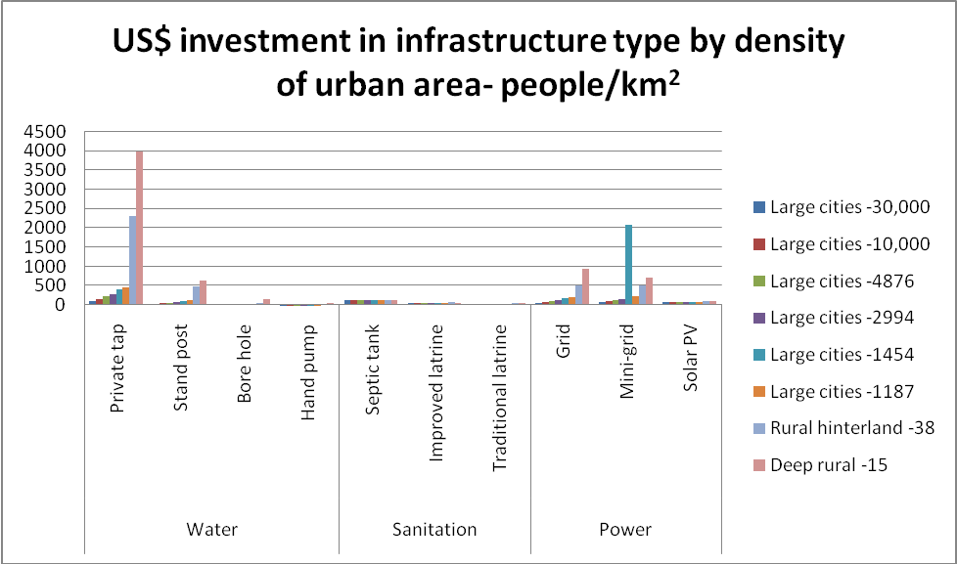

Second, capital costs and salaries are likely to be higher in urban areas, raising the cost of infrastructure provision. Third, urbanization is often associated with a shift toward manufacturing and services production, which calls for greater provision of economically productive infrastructure in addition to universal services (such as ITC, transport links, electricity). Fourth, the fact of urbanization may not translate into increased infrastructure if fiscal constraints prove binding. Many of the world’s larger cities in low-income and emerging market countries reveal dramatic differentials in the quality and quantity of infrastructure available. Many low- and even middle-income groups live in slums or low-income housing developments with far fewer and much lower quality infrastructural services than that provided to upper-income groups. The “water wars” experienced in some cities of Latin America and Asia in the last decade (e.g., Cochabamba, Manila) highlight this phenomenon. Indeed, differentials in the quality of the infrastructure available between rural areas and urban slums are often fairly minimal (see Montgomery et al 2003). However, in net terms, there is likely to be an increased need for infrastructure with urbanization.

Finally, the fact of urbanization entailing the need for new infrastructure does not dictate the cost or nature of the infrastructure required. As noted, one can observe significant differences in the quality of infrastructure. Water can be accessed with boreholes and hand pumps, stand-posts, or through private taps. In providing sanitation, one can see traditional or improved latrines, septic tanks, or sewage networks. Flexibility in the technology (and quality) decided upon for such basic services can significantly reduce the unit cost of infrastructure (see also Box 1).

There are several other ways in which urbanization and density affect the demand for infrastructure. Urban populations shift the consumption locus for both the domestic agricultural sector and imports, spurring demand for storage, distribution, transport and port infrastructure associated with distant agricultural production.

Additionally, cities are rarely static. As a city grows, its existing infrastructure may become inadequate and may need to be upgraded or replaced, creating the opportunity for investing in new approaches for water supply or sanitation or in the way in which the urban transport system is designed. And as density also evolves, particularly as economies mature, per capita incomes rise, and land values become more expensive. Higher densities allow for the substitution of networked infrastructure, enabling both higher quality as well as lower unit costs.

And in many countries, urbanization occurs in coastal or deltaic

Box 1. Urbanization entails new infrastructure, but are there alternative potential approaches?

As urbanization occurs, there are many choices to make about how to invest infrastructure, each with different cost profiles. For example, in the transport sphere, one might consider investments in bus-based mass transit approaches versus large-scale road and rail-based transport infrastructure. In urban development, the Millennium Project considered two alternative approaches. One involved the upgrading of existing slum areas, through upgraded housing, the retrofitting of infrastructure for water supply, and the provision of sanitation, transport and energy services. This approach requires a strong focus on networked technologies in the areas of sewers, piped water and electricity grids, storm drainage, and water storage.

The Millennium Project’s second approach involved the development of new urban sites as an alternative to the formation of new slums. There are significant cost differences between these approaches. The Millennium Project suggests that with slum upgrading, the average investment per person over 15 years (including. physical improvements to housing stock, basic physical infrastructure--water, sanitation, drainage, road paving, and electricity) is about $42 per beneficiary per year. In contrast, providing new urban settlements can cost about $26 per beneficiary per annum, or one third to one half lower than the cost of comprehensive upgrading.

Also, with urbanization, there is a potential for an unbundling of infrastructure services. For example, in relation to sanitation services, for large urban areas, one might consider unbundling a service area into parallel independent service zones, each with its own sewerage network, leading to lower average diameter and average depth for the entire city. This can lead to lower capital costs, stretching funds, and easier management requirements. Bangkok is an example of a mega city where the unbundling of sewerage has been successfully applied.

regions. Particularly for mega cities, increased population pressure may put pressure on ground water levels as well as cause ground subsidence. Over time, the fall in ground water levels will engender the search for alternative sources of water and the construction of dams or reservoirs. Urbanization along the coast will engender demand for coastal protective infrastructure simply because of the higher population and property that is at risk from storm damage (even under current climatic conditions and ignoring, for the moment, the impact that future climate change might have on the intensity and frequency of hurricanes and typhoons). Ground subsidence from higher population settlement loads would of course be the equivalent of a rise in sea level, and thus imply a higher risk from storm surges.

The last demographic factor to consider relates to migration patterns. This is not wholly unrelated to urbanization, since significant migration might derive from movements from rural to urban areas. But substantial migration in or out of a country also influences population size, the number of households, and the age structure, and is thus a factor to consider (positively or negatively) when assessing the influence of demographic factors on the need for infrastructure. Here policymakers should be sensitive to the precise nature of the rural-urban migration process. Does it largely reflect movements from rural to small cities, rather than simply a more direct migration to the capital city? The former may imply the need to provide new infrastructure for small cities, rather than to expand existing infrastructure networks. A more conjectural consideration for policymakers is whether the provision of urban infrastructure and the greater availability of urban amenities might itself prove a factor inducing in-migration to urban areas.

The above heuristic discussion resonates with the empirical literature, where three demographic variables tend to be included in most studies—population size, density, and urbanization rate--and these generally prove statistically significant. Occasionally, population growth enters as well.

Does infrastructure influence demographics?

There is one final dimension to the demography-infrastructure connection that is worth exploring, and this is whether the availability of infrastructure might be an independent factor influencing demographic developments. A number of relations might be posited. Does the availability of higher quality infrastructure influence migration decisions, say from rural to urban areas, or even from low-income to high-income countries? Some countries, notably China, have actively sought to develop cities, with the expectation that the availability of jobs would induce rural to urban migration. Indirectly, since fertility rates tend to be lower in urban areas, the availability of infrastructure might not only influence migration but ultimately fertility rates. Along a similar dimension, the availability of certain types of infrastructure, e.g., separate toilets for girls in primary and secondary school, might set in motion decisions that then influence demographic factors, such as fertility. There is compelling evidence that provision of education to girls does reduce fertility rates and that parents are often deterred from sending girls to school by the absence of separate sanitary facilities. Similarly, an adequate transport infrastructure, particularly in the rural areas, might facilitate access by isolated populations to both education and health facilities. Increasing the likelihood of child survival has long been recognized as a prerequisite for reduced fertility. The issue can be posed from another angle. The absence of infrastructure—adequate roads, primary health clinics, primary schools and so forth—may be an important factor underlying higher morbidity and mortality rates or lower primary school enrollment rates. Such conditions might thus explain the slow pace of the demographic transition observed in the many African countries and in rural areas.

Table 2: Infrastructure availability: in sub-Saharan Africa and other LICs

What do Demographic trends mean for infrastructure through 2050?

What do demographic projections imply about the need for infrastructure investment in the coming decades? Drawing principally on the United Nations Population Division’s (UNPD) recent 2008 population projections (using the medium and high variant assumptions), this section focuses on the expected growth of the overall population, the size of the school age, working-age, and elderly populations, and the urbanization rate (the latter drawn from the UNPD’s 2007 urbanization projections) in three categories of countries, with a special focus on Asia and Africa. These categories represent the different stages of the demographic transition: the transformation of countries from high birth rates and high death rates to low birth rates and low death rates as part of the economic development of a country from a pre-industrial to an industrialized economy.

It is important to keep in mind two deficiencies in the UNPD projections. First, as noted above, the number of households may be more important than the total population size as a variable influencing the demand for infrastructure, and this variable is not included in the UNPD projections. Second, the UNPD’s projections of urbanization appear to be independent of their population projections—most likely they accord with the median variant assumptions. They also appear independent of any projections on economic growth during the projection time frame and do not allow for characterization of density levels. Yet the pace of economic growth influences urbanization rates.

Category 1: High fertility (mostly African) countries

The first category of countries includes those experiencing relatively high rates of population growth. These countries are still in an early phase of the demographic transition (even if they have begun to observe some fall in their fertility rates). Among the countries characterized by the UNPD as experiencing relatively fast rates of population growth are most African countries, including Niger, Burundi, Liberia, Guinea-Bissau, Uganda, Mali, Democratic Republic of Congo, Chad, Afghanistan, Timor Leste, Yemen, Nigeria, Ethiopia, Kenya, Somalia, Burkina Faso, and Tanzania. Policymakers in these countries will experience an obvious need for spatially universal infrastructure (housing, water, sanitation, and basic social services) through the next several decades.

Demographic need alone, however, does not mean that investment in such infrastructure will occur. Despite significant population growth over the last decade, infrastructural investment has lagged in sub-Saharan Africa (Table 1). This infrastructure deficit is largest for traditional areas of infrastructure—power generation, telephone landline availability, electricity coverage, and paved road density. Power consumption in Africa is only 10 percent of that in other low-income countries (at 123 kwh per capita per year)—and falling. Since 1990, there has been little change in the share of the population with access to landline telephones, flush toilets or piped water and only small improvements in the fraction of the population with access to electricity (increasing from only 22 percent to 28 percent). Rapid urban growth has left “infrastructure service providers severely stretched, [with the]…resulting gap [in water and sanitation] filled by lower cost alternatives such as boreholes and pit latrines” (Foster, 2008, p. 3). Only for relatively new types of infrastructure, such as mobile phone and Internet density, are the gaps with other low-income countries lower.

Table 1: Infrastructure availability: in sub-Saharan Africa and other LICs
 | Sub-Saharan Africa | Other LICs
Paved road density (km/km²) | 31 | 134
Total road density (km/km²) | 137 | 211
Mainline density (lines/1000 inhabitants) | 10 | 78
Mobile density (lines/1000 inhabitants) | 55 | 76
Internet density (lines/1000 inhabitants) | 2 | 3
Power generation capacity (MgWt/M³inhabitants) | 27 | 326
Electricity coverage (percent of population) | 16 | 41
Improved water (percent of population) | 60 | 72
Improved sanitation (percent of population) | 34 | 51
Source: Foster (2008), p. 2

In Africa, any kind of economic takeoff will require, at a minimum, filling existing infrastructure gaps, particularly in the power sector. Beyond that, there remains the challenge of providing infrastructure to meet the needs of a rapidly growing population. After 2025, while the increase in the size of the school age population is less than half that of the previous two decades, there will still be a significant absolute increase. And more crucially, there will be an enormous increase in the working age population in Africa—at least 433 million and most likely higher (under the high population variant). Absent the necessary complementary economic infrastructure, the private sector in Africa will face an enormous challenge in providing employment for this burgeoning work force.

If fertility remains high in category one countries, policymakers will confront the classic uphill battle associated with continuing growth in demand for spatially universal infrastructural services while they are still saddled with high dependency burdens limiting the availability of savings. In contrast, if fertility rates begin to fall, as the UNPD projects that they will, these countries will begin to observe, by 2025, a fall in dependency rates and a rising share of their populations in the working age group, with the implied shift in the character of the composition of infrastructure demand (see Chart 3). The virtuous circle of the demographic transition would begin to be revealed, yielding at least the potential for higher savings and investment rates, and a higher economic growth rate associated with an increase in the labor force.

Also noteworthy, the UNPD projections suggest that this group of countries will begin to experience significant urbanization, particularly in the second quarter of this century (see Chart 3), with the bulk of the urban population likely to be dominated by those of working age. This suggests the relatively greater importance of providing economic infrastructure—power, telecommunication, and transport— to facilitate increased private investments in services and manufacturing, rather than responding to the need for spatially universal services infrastructure. Reflecting the low level of per capita income in these countries, the economic pressures for high density settlements will be relatively small, implying limits on the ability of governments to install large-scale infrastructural service networks.

Chart 3: Rapid urbanization dominated by working age population groups

The UNPD also suggests that despite increasing urbanization in these countries, there will still be a growing number of persons living in rural areas, particularly over the next twenty years. (See also Chart 4). Rural infrastructure will be needed both to address dramatic existing deficiencies as well as to respond to the growth in the absolute size of the rural population. For the rapidly growing population countries—Niger, Burundi, Guinea-Bissau, Uganda, Ethiopia, Kenya and to lesser extent Tanzania, Democratic Republic of Congo, and Afghanistan—connective transport infrastructure will also be important, allowing rural areas to export their agricultural produce to urban centers at low cost.

Chart 4: Countries in the early phase of demographic transition: rapid urbanization but rural areas still important

Category 2: Countries (mostly Asian) with some reduced fertility

The second category of countries (which, with the exception of Egypt, are in South or Southeast Asia) includes those where population growth is still high but where there has already been a demonstrated reduction of fertility. These countries, definitely much further along the path of demographic transition than category 1 countries, include Pakistan, Bangladesh, India, Philippines and Egypt. These countries will still experience significant absolute increases in population through 2050, but unlike the previous category of countries, both the share of the working-age population and the dependency rate will remain unchanged throughout the period. But these countries will also begin to observe a significant shift in their population structures towards the elderly and away from the youngest age group. They will also begin to observe a dramatic shift, particularly after 2025, in the urbanization rate, with a sharp fall in their rural populations (see Chart 5).

Chart 5: Countries where urbanization will begin to deplete rural areas

The higher urbanization rate in these lower-middle and middle-income countries may entail higher per capita infrastructure costs, mostly reflecting the demand for higher quality offsetting the savings from economies of scale associated with higher-density settlements. Also noteworthy for this group of countries, will be the still substantial growth in their rural populations through 2025, particularly in India, Pakistan and Egypt, even though this rural population growth will be dwarfed by the growth in their urban populations. This will require universal services infrastructure to provide water and sanitation as well as spatially connective transport infrastructure. However, the dramatic decline in the size of their rural sector after 2025 suggests that policymakers may wish to place limits on both the quality and quantity of infrastructure that would be provided in the rural areas for the next decade or so. Otherwise, much of the infrastructure may prove costly and inefficient, given the shifting weight of the population towards urban areas.

For Asia specifically, where infrastructure provision has been dynamic in recent decades, the demand for new infrastructure will principally center on strengthening transport routes and extending modern ICT infrastructure. In terms of absolute population growth through 2025, Asia continues to dominate, with the medium-variant population growth equaling 836 million persons (compared to 479 million in Africa). But in the subsequent 25 years, this dominance will likely reverse, with a significant slowing in Asia’s population growth (with an increase by 459 million over these 25 years relative to 599 million in Africa during the period). Thus, there will be a high need for spatially universal infrastructure in Asia, with high necessary levels of investment since these countries have higher per capita income levels and are more densely urbanized.

In Asia, the urban population is projected to grow by more than double the total population growth (1.05 billion versus 460 million), and the growth of the 60+ elderly population—at 540 million—will account for half of that urban population growth (See Chart 6). In contrast, in Africa, the growth in the urban population, at 575 million, is only somewhat higher than the growth in the working age population. Thus, in Asia, the challenge will be less in the expansion of infrastructure to provide complementary capital for the work force and more in the upgrading of infrastructure associated with higher valued added jobs and the need for an infrastructure that can meet the needs of an elderly population (with presumably greater levels of household units per capita).

Chart 6: Advanced demographic transition: rural areas losing population and shift of urban population toward the elderly

Also over the next 20 years, there will be a high demand for economic infrastructure in Asia, with an increase of 533 million in the population in the productive age group in. Given the lower degree of risk associated with investments in Asia (due to the lower cost of doing business by any set of governance indicators), one might expect a far greater share of private capital flows to be drawn to investments in the Asian region, whether in terms of purchases of Asian sovereign debt instruments or in terms of participation in public-private partnerships (Table 2).

The only factor arguing against this higher pressure for infrastructure spending in Asia is in relation to the demand for educational infrastructure. Asia is expected to witness an absolute decline in its 0-14 school-age population (relative to the still large growth of 125 million in Africa’s school-age population). There will presumably be a need for secondary and tertiary educational infrastructure in Asia, but again, the demand pressure can be expected to slow.
This suggests the need for a rationalization of the educational infrastructure rather than any new construction.

Table 2. Projected annual infrastructure investment needs: Africa and Asia: 2008-18
(As a percent of GDP per annum)
 | Africa |  | Asia
Annual required spending | New | O&M | New | O&M
Information and communication technologies | 0.1 | 0.1 | 0.5 | 0.9
Irrigation | 0.2 | --- | -- | --
Power | 4.2 | 2.4 | 2.0 | 1.0
Transport | 1.7 | 1.5 | 0.9 | 0.5
Water and Sanitation Services | 0.4 | 1.2 | 0.2 | 0.4
Total | 6.9 | 5.2 | 3.6 | 2.8

Chart 7: Median-variant UNPD Population Projections by Age Group: 2005-2050
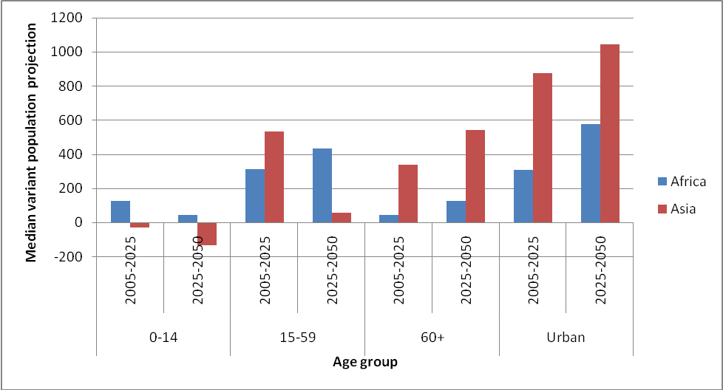

Category 3: Low fertility countries

Countries in the third category are well advanced in their demographic transition and have now experienced low fertility rates for a considerable period of time. They include, most notably, such prominent countries as China, Mexico, Brazil, and Indonesia, and more recently, Vietnam (see Chart 5). While the UNPD projects an increase in the overall population of these countries in coming decades, one should also observe a sharp decrease in the share of the younger age group and a substantial increase in the share of the elderly population, implying also an increase in the number of household units per capita. This would be matched, most importantly, by a large drop in the share of the working-age population, implying an increase in the overall dependency rate and signifying the end of the period when the demographic transition affords the dividend of a higher potential savings.

These countries will also experience a substantial increase in the urbanization rate—mostly of high density—and an absolute population decline in rural areas even in the next decade or so.
For these countries, one would expect, over time, a deceleration in the growth in demand for economic infrastructure and an increase in the demand for spatially universal infrastructure, reflecting a higher level of urbanization and an increasing number of household units. With rising incomes in these countries, one would also expect a demand for an upgraded quality of infrastructure in the rural areas, reflecting the convergence in infrastructure standards that arise at higher income levels. A particularly interesting challenge for these countries (as well as the aging industrial world) is how to adapt certain elements of the infrastructure of urban areas to accommodate an aging (and even shrinking) population (see Box 2).
Box 2: Singapore: Approaches to the Adaptation of Infrastructure for an Aging Population

In many industrial and middle-income countries, the coming decades will see a large increase in both the absolute numbers and the share of the population of the elderly relative to other segments of the population. Many of the elderly will be retired; others will be working part-time. Increasingly, many will fall in the category of very elderly, particularly in industrial countries. Singapore is one of the few countries to have comprehensively assessed the implications of a substantial number of elderly on infrastructure.

In 2007, its Committee on Ageing Issues: Report on the Ageing Population provided guidelines on these issues. Among the recommendations:

- Prepare guidelines on providing accessibility and safety features in the homes for seniors.
- Make all new public buses low floor step-free and wheelchair-accessible to allow everyone to use the public transport system.
- Expand and accelerate the upgrading and improvement of existing barrier-free measures on road facilities to enhance accessibility between destinations.
- Establish a new intermediate government residential care facility to address the current service gap in intermediate residential care for seniors.
- Develop integrated models of day care and day rehabilitation centers, based on market driven needs, to provide more client-centric and efficient services.

How should policymakers decide where to invest?

This paper was prompted by the question of how policymakers should take demographic factors into account in considering their infrastructural investment priorities. Understandably, demographic factors are not alone among the issues that will (or should) shape infrastructural decisions. Policymakers must weigh many considerations when deciding where to invest, including, as discussed earlier in this paper, infrastructure most likely to spur economic growth, the demands of technology, sociological issues, fiscal issues, and climate change.

Money is perhaps the most binding constraint. Governments must consider whether fiscal resources will be adequate to finance infrastructure investments, taking into account an overall perspective on what is a sustainable level of government borrowing over the long-term. Making such an estimate is not easy, since in principle, highly productive infrastructure investments can raise the potential growth rate and thus enhance the level of investment that might be fiscally sustainable (see Buiter, 2004 for an approach to estimating fiscal sustainability).

One approach to judging whether fiscal sustainability considerations might limit the potential for infrastructural investments is to compare the real growth of the economy with the rate of urbanization. For countries where urbanization growth rates are more rapid than that of real growth, one might question whether the increase in government revenue will be sufficient to finance the needed amount of infrastructure. This issue is particularly relevant in countries where the share of the urban population is relatively high.

Graphs 2 and 3 provide a simple characterization of this issue, comparing real growth rates during the period 2000-07 with the projected annual growth of the urban population during the periods 2005-10 and 2025-30, respectively. The graphs are drawn such that countries above the line have higher real growth rates during 2000-07 than the projected urbanization rate for 2005-10 or 2025-30.

These graphs suggest that a number of countries—notably Haiti, Madagascar, Burundi, Nepal, Yemen, Malawi, Eritrea, Liberia, and Comoros—will evince current real economic growth rates less than their projected urbanization rates in the future. Several other countries—Kenya, DRC, Benin, Guinea Bissau, Niger, and Cameroon—were able to realize current real growth rates roughly comparable to their projected annual urbanization rates. However, even these countries may be hard pressed not only to keep up with the infrastructure requirements associated with urbanization, but also to make up for the significant infrastructural backlog that they have allowed to develop over the last decade or so.

Graph 2: Comparing current economic growth rates with projected urbanization: 2005-10

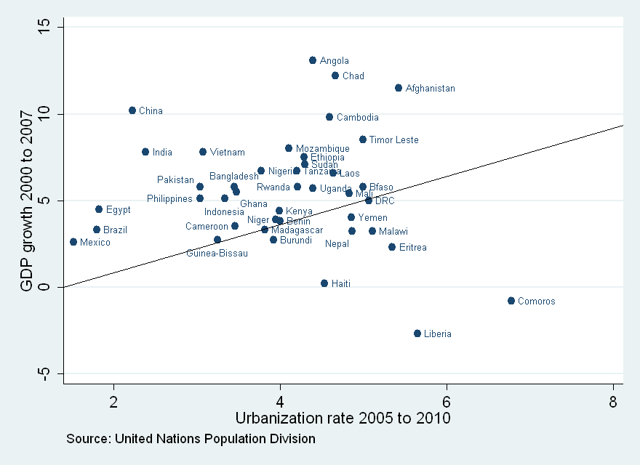

Graph 3: Comparing current economic growth rates with projected urbanization: 2025-30
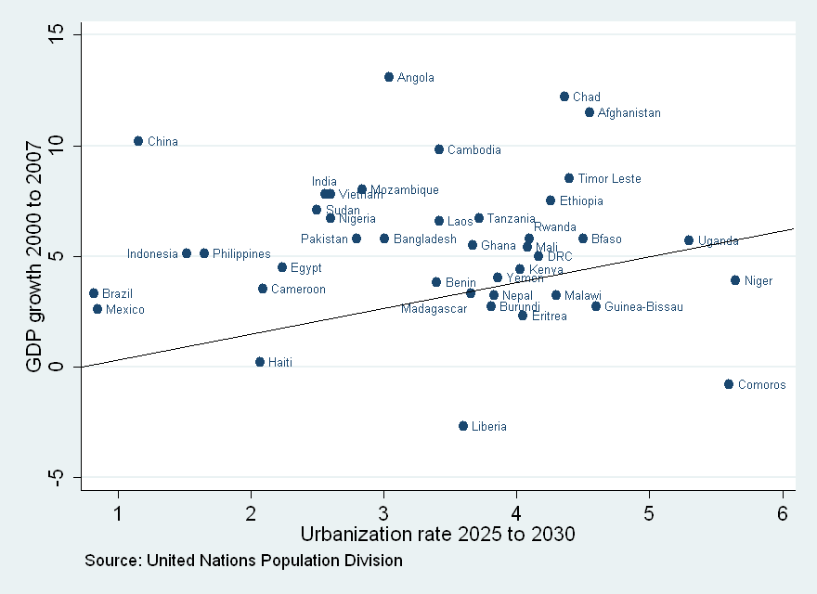

Other factors that interact with demographic trends will also play an important role in influencing policymakers’ infrastructural choices in coming decades, and most important of these is climate change. Particularly for Asian countries, the interaction of urbanization and climate change will pose significant challenges to the viability of coastal cities and will require either coastal protection investments or revised settlement patterns. The combination of socioeconomic development, population growth, and the possibility of human-induced subsidence in these urban centers will dramatically increase the exposure of a number of cities—both in terms of population numbers and the value of assets—to the impact of flooding, storm surges and wind damage, even in the absence of the higher sea level and increased storm intensity associated with climate change (Nichols et al 2008).

The increase in population alone could result in a 150 percent increase in the number of persons exposed to the risk of a one in a hundred year storm, even with no other factors involved (40 million in 2000 to 95 million in 2070). If one were to include the impact of higher storm intensities, the rise in sea level, and the effects of human-induced subsidence, then the population at risk would increase to 140 million. Similarly, the value of urban assets at risk during the period will rise from $3 trillion to $35 trillion over the period. Low-income countries in Asia and Africa will face the brunt of the exposure to such risks, due to their minimal existing flood/coastal protection infrastructure, the sharp increase in the size of these population centers, the limited urban land-settlement programs, and the rapid projected socioeconomic development. Drawing from the study by Nichols et al (2008), Map 1 indicates the Asian, African, and South American coastal cities with maximum risk exposure in terms of the population at risk.
Chart 6: Asian and African cities among the top 30 cities with maximum exposure in terms of population at risk to sea level rise and climate change

Asian non-MDC cities Africa
Kolkata Alexandria
Mumbai Lagos
Dhaka Abidjan
Guangzhou
Ho Chi Minh City South America
Shanghai Guayaquil
Bangkok
Rangoon
Haiphong
Tianjin
Khulna (Bangladesh)
Ningbo
Chittagong (Bangladesh)
Jakarta
Shenzen
Qingdao

Source: Nichols et al (2008)

Map 1: Cities with maximum exposure in terms of population at risk to seal level rise and climate change

Similarly, Map 2 shows the top 19 world cities with the highest proportional increase in the value of the assets at risk by 2070 relative to the current situation. Among these cities, 17 are in Asia

Map 2: World cities with highest proportional increase in exposed assets at risk by 2070 relative to current situation

Chart 7: Among top 20 worl cities with highest proportional increase in exposed assets at risk by 2070 relative to current situation, 19 are in Asia

Asia
Ningbao Jakarta
Dhaka Zhanjiang
Kolkata Haiphong
Fuzhou Bangkoik
Tianjin Shanghai
Surat Ho Chi Minh City
Xiamen Shenzen

Guangzhou South America
Mumbai Guayaquil
Hong Kong
Africa
Alexandria

Source; Nichols et al (2008)

Source: OECD (2008)

IV Policy implications

But what specifically should individual countries do? How should policymakers answer questions such as: what infrastructure is needed for a country to become competitive or to maintain competitiveness or attract FDI? What infrastructure is required to restructure modes of energy generation or to adjust to higher future carbon prices? How should water infrastructure needs be prioritized, particularly in view of the impact of climate change on general water availability? What policies are needed to render infrastructure both affordable and profitable in the context of still sizeable low-income populations?

The World Bank’s World Development Report 2009, which focuses on spatial issues in development, suggests that efforts at leading the market are not often successful. In the past, construction of urban centers that lacked an underlying economic rationale—with the expectation that such centers would attract both a labor force and private investment—have often proven unsuccessful as a strategy for development. Equally, while the MDGs imply equal access and quality standards for spatially universal infrastructure, there may be a high opportunity cost implied in terms of foregone growth if there is less investment in economic infrastructure that can facilitate job creation.

Jeffrey Sachs, in his UN Millennium Project report, argues that with scarce fiscal space, it is critical to achieve some “quick-wins”—providing access to electricity, water, sanitation and the Internet for all hospitals, schools, and other social service institutions. He suggests the use of off-grid diesel generators, solar panels, or other appropriate technologies (UN Millennium Project, 2005). He also argues for combining a growth focus with broader MDG objectives. For example, he notes that a new green revolution in rural areas will require improved rural infrastructure services in the form of roads and other means of transport (the construction and rehabilitation of footpaths, feeder, district, and national roads), modern energy services, and communication technologies.

Box 3: Mumbai and Shanghai: An Examples of Successful Urban infrastructure

- Mumbai: three local associations formed an alliance to raise the political visibility of issues affecting the poor and to promote creative solutions, particularly with respect to land tenure, adequate housing, and access to electricity, transport, sanitation and related services. Precedent-setting pilot projects were used to show feasible low-cost designs for affordable housing and sanitation.

- Shanghai: a city that took steps early to address risks associated with sea level rise; also has been suggested as an example of a large city confronting its service and infrastructure challenges in an energetic and innovative fashion. The central government gave the city more autonomy in revenue collection and expenditure. Also the city established a foundation to mobilize funds for urban construction (Shanghai Urban construction Investment and Development Company), which is said to have displayed an “impressive record of achievement in infrastructure financing since its creation.” (Montgomery, p. 366). The most spectacular outcome is the development of the Pudong New Area, which is virtually a completely new district from the old commercial center. Shanghai has also employed a wide range of financing mechanisms through such state and non-state channels as international capital, bank loans and credits, construction bonds, the stock market, and service concessions. The city entered into concessions with profit-making enterprises to operate three bridges and a tunnel across the Huanpu River and established subordinate entities in charge of water supply. There are still severe backlogs on the housing side for low-income groups, despite the impressive delivery of urban services and urban infrastructure improvement.

Source: Montgomery et al (2003)

Recent World Bank research on infrastructure in Africa (Foster, 2008; Foster et al, 2009; Calderon and Servén, 2008) suggests a number of further considerations that might help policymakers respond to the pressures arising from demographic factors.

- First, most studies on rates of returns to infrastructure investments suggest that the realized returns are greatest when investments are able to remove critical bottlenecks in supply. For example, in the sphere of water storage, achieving water security for urban areas with high growth potential may need to be the highest priority. This in itself suggests that policymakers might need to prioritize key economic infrastructures ahead of satisfying demographic demand pressures. But one can imagine contexts, particularly in the urban sphere, where specific investments could remove bottlenecks in the area of basic services in water, sanitation, and power.

- World Bank research also shows that the unit cost of infrastructure is highly sensitive to density. Policymakers will need to be flexible in terms of the quality and standards of infrastructure they choose in order to accommodate the needs of lower density settlements. This may imply the need to invest in lower quality standards of infrastructure that are also of lower unit cost (see Foster and Briceño Garmendia, 2009). Compromising on quality standards may facilitate more effective exploitation of the limited fiscal space available in order to achieve both the provision of universal services and the satisfy demands for job creation.

- Policy reforms, particularly in pricing structures (usually involving cross subsidies) may be necessary to facilitate adequate cost recovery to support the provision of infrastructure related to water and energy. Indeed, one could argue that infrastructural investments, unaccompanied by good policies, are likely to be inefficient and prone to failure. Installing infrastructure without responding to user preferences or the capacity of users to pay for acquisition, operation, and maintenance operations, are unlikely to be successful.

- World Bank research suggests that higher spending levels on infrastructure are possible if greater efficiencies can be realized. They note the pressure of institutional bottlenecks, monopolistic practices raising costs, inadequate tendering processes, and weak operations and maintenance procedures, all of which force spending on new investments rather than on less costly maintenance.

- Some kinds of infrastructure will be heavily influenced by both spatial and fiscal constraints. For example, in Africa, population densities are low and distances between urban agglomerations great. This implies that the high cost of realizing comprehensive road networks—both for investment and operations and maintenance—will make it difficult for countries to significantly upgrade or add to their existing networks. Low per capita income levels imply a relatively low value of time, undercutting the demand pressures for reducing the time involved in transport that often justify investments in higher quality roads.

- Where infrastructural access is weak, policymakers will need to clarify the reasons why this is so. Does it reflect demand-side constraints arising from the low incomes of households and their inability to afford unsubsidized infrastructural services? Or does it reflect supply-side factors, such as the unavailability of infrastructural services or inappropriate infrastructure design (Wodon et al, 2009)?

- Policy choices on infrastructure can be made for the wrong reasons. In many low-income countries, one observes corruption, collusion between donors (seeking export promotion favoring industrial interests) and politicians, seeking graft and a focus on prestige projects. The high value of the contracts for infrastructure spending often leads to rent-seeking and the inappropriate absorption by the public sector of contingent fiscal risks in the negotiation of PPP contracts.

- Finally, and responding to the issue of demographic factors, one would hope that an awareness by policymakers of the cost of infrastructure—the need to provide basic infrastructural services—might sensitize them to the importance of considering demographic factors, and in particular, the level of fertility. By failing to limit population growth, they will find that the resources that might go into investments that could spur growth are instead required to be used for the provision of basic infrastructure.

Conclusion

Demographics matter. In the 21st century, with the Millennium Development Goals enshrined as a minimum set of welfare targets, countries with growing populations must be prepared to provide a basic network of water, sanitation and social services. The projected rapid pace of urbanization also implies the need to accommodate this population movement and provide such services in places where they have hitherto not been provided. For many countries, this will also require investments to fill the outstanding backlog of infrastructure facilities.

The paper has also argued that beyond universal services infrastructure, the shifting age structure of the population, particularly the rising number of working age people, will require countries to provide economic infrastructure that can attract private sector investments and facilitate the creation of jobs. Urbanization will not only require the creation of jobs in urban centers but also necessitate the availability of infrastructure to exploit the production potential of rural areas in the agricultural and forestry sectors.
References
Agénor, Pierre-Richard and Blanca Moreno-Dodson, 2006, Public Infrastructure and Growth: New Channels and Policy Implications (World Bank Policy Research Working Paper No. 4064)

Asian Development Bank, Connecting East Asia: A New Framework for Infrastructure (2005)

Borcherding, Thomas and Robert T. Deacon, 1972? “The Demand for the Services of Non-Federal Governments,” American Economic Review, 62(5), pp. 891-901)

Buiter, Willem, 2004, Fiscal Sustainability (Speech delivered to the Egyptian Center for Economic Studies) (available on the web).

Calderon, César, 2008, Infrastructure and Growth in Africa (AICD Working Paper, World Bank, Washington DC).

Calderon, César and Luis Servén, 2008 Infrastructure and Economic Development in Sub-Saharan Africa, Policy Research Working Paper 4712 (World Bank)

Canning, David and P. Petroni, 2004, The Effect of Infrastructure on Long-Run Growth (unpublished)

Chu, C.Y. Cyrus, “Population Density and Infrastructure Development,” Review of Development Economics, 1(3), pp. 294-304, 1997

Dasgupta, Susmita, Benoit Laplante, Craig Meisner, David Wheeler, and Jianping Yan, 2007, The impact of sea level rise on developing countries: a comparative analysis, Policy Research Working Paper 4136 (World Bank)

Estache, Antonio, 2006, Infrastructure: A survey of recent and upcoming issues

Estache, Antonio, Biagio Speciale, and David Veredas, 2005, How much does infrastructure matter to growth in Sub-Saharan Africa,

Estache, A., B. Speciale, D. Veredas, 2005, How Much does Infrastructure Matter to Economic Growth in Sub-Saharan Africa, (unpublished, World Bank)

Fay, Marian and Tito Yepes, 2003, “Investing in Infrastructure: What is needed from 2000 to 2010,” Policy Research Working Paper No. 3102 (World Bank)

Foster, Vivian, 2008, Overhauling the Engine of Growth: Infrastructure in Africa (World Bank, September, 2008, unpublished)

Foster, Vivian. and C. M. Briceño Garmendia, 2009, "Africa's Infrastructure: A Time
for Transformation", Africa Infrastructure Country Diagnostic, World Bank,
Washington DC (forthcoming).

Heller, Peter, Operations and Maintenance Issues in Indonesia (unpublished, 1989)

Hemming, Richard, M. Alier, B. Anderson, M. Cangiano, and M Petri, 2006, Public-Private Partnerships, Government Guarantees, and Fiscal Risk (IMF, Washington DC)

IMF, World Economic Outlook (April 2008)

IMF, Public Investment Policy (2004)

Mason, Andrew, 2001, Population Change and Economic Development: What Have We Learned from the East Asia Experience (East-West Center Working Paper No. 01-3)

Montgomery, Mark, Richard Stren, Barney Cohen, and Holly E Read, ed., 2003, Cities Transformed: Demographic Change and Its Implications in the Developing World (The Washington DC: National Academies Press,

Nichols, R, S. Hanson, C. Herweijer, N. Patmore, S. Hallegatte, J. Corfee-Morlot, J. Chateau, R. Muir-wood, 2008 “Ranking Port Cities with High Exposure and Vulnerability to Climate Extremes,” Environmental Working Paper No. 1 (Paris: OECD)

Pinstrup-Andersen, Per and Satoru Shimokawa, 2006, Rural Infrastructure and Agricultural Development (paper prepared for Annual Bank Conference on Development Economics, Tokyo, 2006).

Ramachandran, Vijaya, Center for Global Development, 2008 “Power and Roads for Africa: What the United States Can Do,” White House and the World Policy Brief, , http://www.cgdev.org/content/publications/detail/16557

Seethpale, K., M. Bramati, and D. Veredas, 2008, “How Relevant is Infrastructure to Growth in East Asia,” Policy Research Working Paper No. 4597(World Bank, Washington DC)

United Nations Population Division, Population Forecasts 2006, Urbanization Forecasts
World Bank, 2008a, World Development Report 2009 (Washington DC: The World Bank)

UN Millennium Project, 2005, Investing in Development: A Practical Plan to Achieve the Millennium Development Goals (New York: United Nations Development Programme)

UN Millennium Project, Task Force on Improving the Lives of Slum Dwellers: A Home in the City (2005)

UN Millennium Project, Task Force on Water and Sanitation, Health, dignity and development: What will it take? (2005)

UN Millennium Project, Energy Services for the Millennium Goals, (2005)
UN Population Division: World Population Prospects: The 2008 Revision Population Database

UN Population Division: World Urbanization Prospects: the 2007 Revision

Wodon, Q., S. Banerjee, A. Diallo, and V. Foster, 2009, “Is Low Coverage of Modern Infrastructure Services in African Cities due to Lack of Demand or Lack of Supply,” World Bank Policy Research Working Paper No. 4881

World Bank, 1993,World Development Report 1994: Infrastructure for Development
World Bank, 2003, World Development Report 2004: Drinking Water, Sanitation, and Electricity

World Bank, 2004, World Development Report 2005: Finance and Infrastructure
World Bank, 2008 World Development Report, 2009: Geography in Motion

Yepes, T., Pierce, J. and Foster, V. 2009, Making Sense of Sub-Saharan Africa’s Infrastructure Endowment: a benchmarking approach, World Bank Policy Research Working Paper No. 4912

Yepes, T, 2008, Investment Needs for Infrastructure in Developing Countries 2008-15
(World Bank, unpublished draft).

Yepes, T., 2008, Expenditure on Infrastructure in East Asia Region, 2006-2010 (World Bank).

* The author is Senior Adjunct Professor of International Economics, The Paul H. Nitze School of Advanced International Studies, The Johns Hopkins University. The paper also benefited from the skill research assistance of Fred Selck and from helpful comments by Rachel Nugent, and other participants in a recent conference on Population, Reproductive Health, and Economic Development in Dublin in early January 2009.
These alternative ways of spending are substitutable to some extent: heavy initial investment outlays may reduce the amount of annual O&M required to service infrastructure or lengthen the periods over which rehabilitation outlays are required. Investment that has a limited life span may require more frequent O&M and rehabilitation outlays (see Heller, 1988).
Similarly, in the area of sanitation, the U.N. Millennium Project notes the difference in costs and environmental impact associated with the use of pour-flush systems (as introduced in the Sulabh program in India) as opposed to flush toilets. The former reduces the quantity of water demanded and the quantity of wastewater produced. They also note the different options that exist for off-site sanitation systems, including wastewater conveyance (a simple sewer system), primary treatment systems (sludge drying beds and Imhoff tank), secondary treatment systems (trickling filters, sludge digesters, co-composting of sludge with garbage), and other alternative treatment options (constructed wetlands, in-stream wetlands, and waste-stabilization ponds).
These U.N. Millennium Project estimates are for a minimum package of services in which low service levels are applied for rural populations and intermediate service levels are applied for urban populations, with the vast majority of need assumed to be in peri-urban areas and slums. The U.N.M.P. also estimates that for a sample of low-income countries (Bangladesh, Cambodia, Ghana, Tanzania, and Uganda), it would cost roughly $5 - $7 per capita annually to meet the MDGs relating to water and sanitation, $2 -$4 per capita annually to improve the lives of slum dwellers, $11 -$19 per capita annually to meet the energy needs related to the MDGs, and $21 per capita annually to meet the cost of roads.
One has seen in Africa some commercial private involvement principally in the area of telecommunications, e.g., in East Africa.
In the area of water supply and power, the problem of leakage—of illicit connections—has challenged efforts of private sector firms to be profitable.
Note that each inch of sea level rise is associated with a five-inch rise in the level of the associated storm surge in heavy storms (see D. Wheeler, 2006).
Foster and Briceño Garmendia, 2009), p. 9.
Source: Foster and Briceño Garmendia (2009) Units: US$ per capita.
The medium-variant scenarios assume a gradual reduction in fertility rates to close to 2 over the next 40 years in countries that have high fertility rates. For sub-Saharan African countries, such projections may be optimistic, assuming too rapid a fertility rate reduction. The high-variant assumptions assume fertility rates of at least 0.5 above the median-variant assumption. These are used in some of the projections provided below.
See “Power and Roads for Africa: What the United States Can Do,” White House and the World Policy Brief, Vijaya Ramachandran, Center for Global Development, 2008, http://www.cgdev.org/content/publications/detail/16557
For countries with only a small urban share, a high rate of urbanization in excess of the real growth rate would not necessarily imply that the growth in revenues was insufficient to finance the needed urban infrastructure.
Source: Nichols et al (2008). Asian non-MDC cities: Kolkata, Mumbai, Dhaka, Guangzhou, Ho Chi Minh City, Shanghai, Bangkok, Rangoon, Haiphong, Tianjin, Khulna, Ningbo, Chittagong, Jakarta, Shenzen, Qingdao. Africa: Alexandria, Lagos, Abidjan. South America: Guayaquil
Source: Nichols et al (2008). Asia: Ningbo, Dhaka, Kolkhata, Fuzhou, Tianjin, Surat, Xiamen, Guangzhou, Mumbai, Hong Kong, Jakarta, Zhanjiang, Haiphong, Bangkok, Shanghai, Ho Chi Minh City, Shenzen. South America: Guayaquil. Africa: Alexandria.
Though there are exceptions. Korea has been often cited as a country that has successfully managed to use infrastructure to facilitate a decentralized and successful urbanization process. Several cities—notably Shanghai, Mumbai and Bangkok—are often cited as handling well their development as mega cities (Box 3).

